**Features of a Scripting Language**

Scripting languages are programming languages designed for integrating and automating tasks within a system, often interpreted rather than compiled. Here are key features:

1. **Interpreted**:
   * Scripting languages are usually interpreted, meaning the code is executed line by line at runtime (rather than being compiled into machine code beforehand).
   * **Example**: Python, JavaScript.
2. **Ease of Use**:
   * They often have simpler syntax and are more user-friendly, making them easier for beginners to learn.
   * **Example**: JavaScript for web development.
3. **High-level**:
   * Scripting languages tend to abstract away low-level machine details, making them more intuitive and easier to write compared to low-level languages like C.
4. **Dynamically Typed**:
   * Variables do not require explicit declaration of types, allowing greater flexibility in writing code.
   * **Example**: In Python, you can declare a variable without specifying its type, like x = 5.
5. **Platform Independence**:
   * Many scripting languages are platform-independent because they rely on an interpreter, allowing the same script to run on different operating systems.
   * Example – Python, JavaScript

**How Markup Language is Different from Scripting Language**

A **markup language** and a **scripting language** serve different purposes in the world of web development and software:

**1. Purpose:**

* **Markup Language**: Used to **structure and present content**. It defines the layout, organization, and appearance of text, images, and other elements in a document.
  + **Example**: HTML (HyperText Markup Language) defines the structure of web pages, including headings, paragraphs, links, and multimedia.
* **Scripting Language**: Used to **add behavior and interactivity** to a web page or application. It manipulates the content or data dynamically.
  + **Example**: JavaScript adds interactivity to a webpage, such as handling user clicks, validating forms, and making API calls.

**2. Syntax and Usage:**

* **Markup Language**: Uses **tags** to define elements. It is generally declarative and does not include logic or computation.
  + **Example**:

html

CopyEdit

<h1>This is a heading</h1>

<p>This is a paragraph.</p>

* **Scripting Language**: Includes **logic and programming constructs** (like loops, conditionals, functions, etc.) to process data or control the flow of actions.
  + **Example**:

javascript

CopyEdit

document.getElementById("demo").innerHTML = "Hello, World!";

**3. Execution:**

* **Markup Language**: Is not executed, but rendered by a browser or other rendering engines. It only structures the content, without logic or behavior.
* **Scripting Language**: Is **executed** by an interpreter or runtime environment (like a browser, server, or terminal), allowing for dynamic changes and interactions.

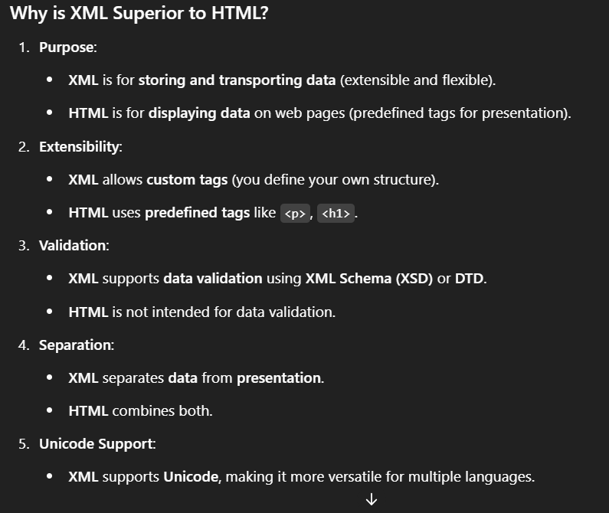

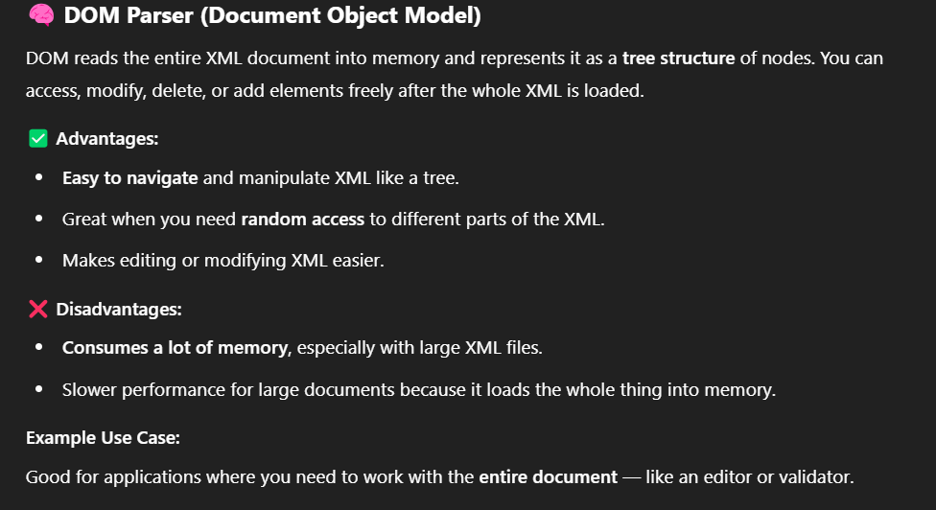

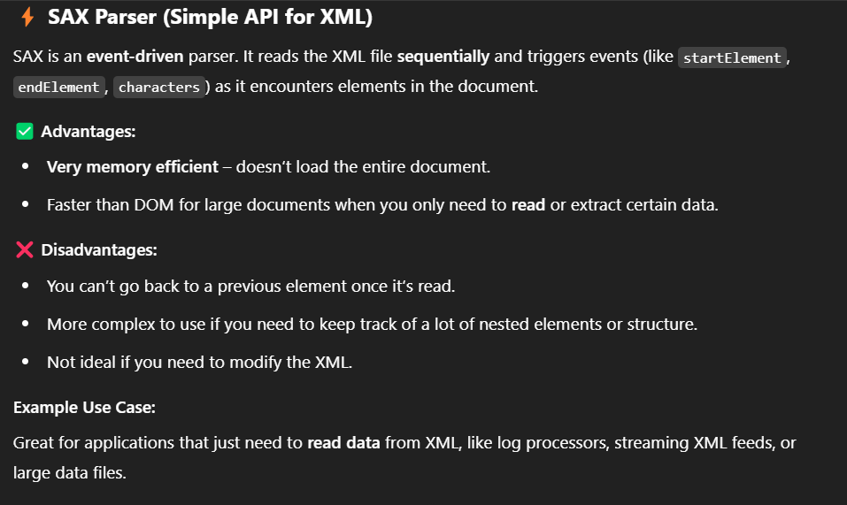

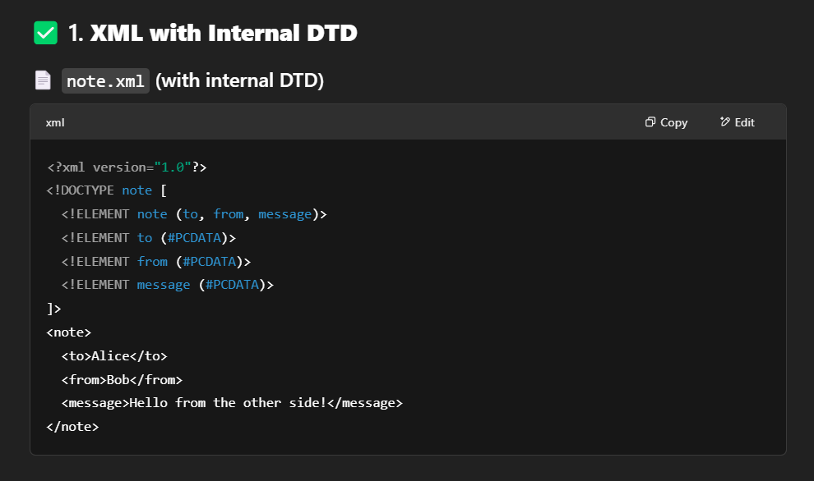

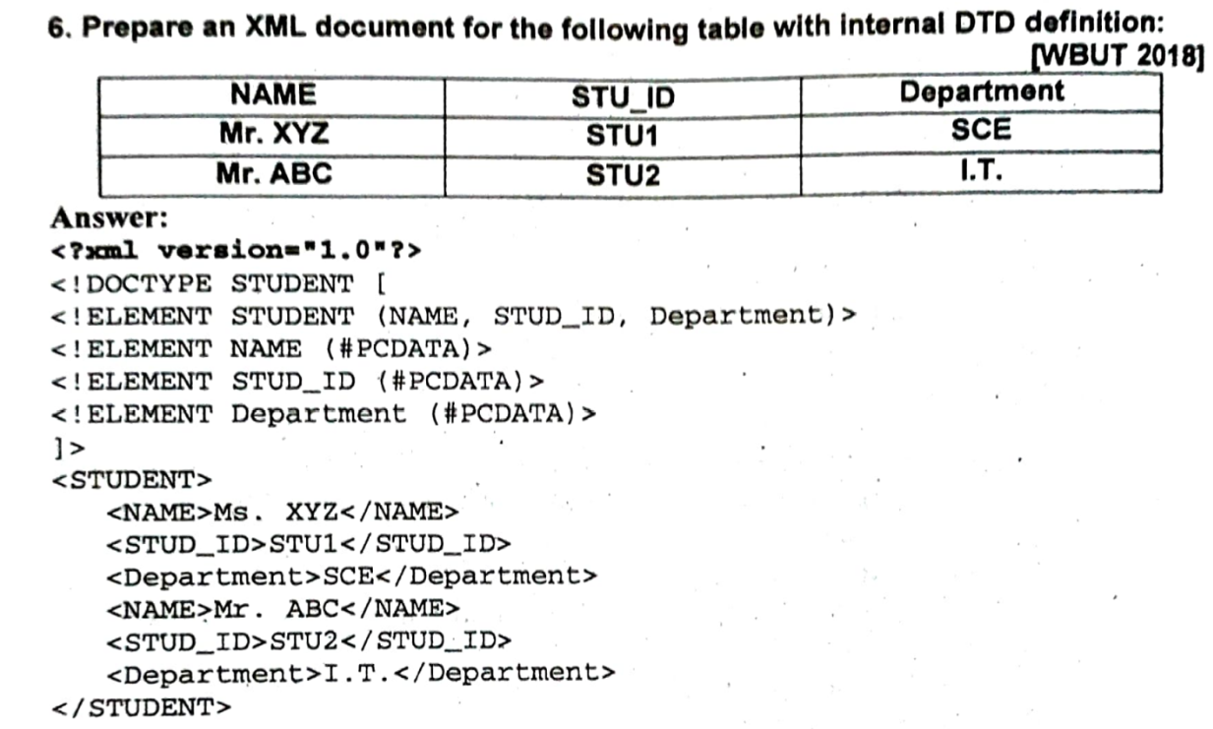

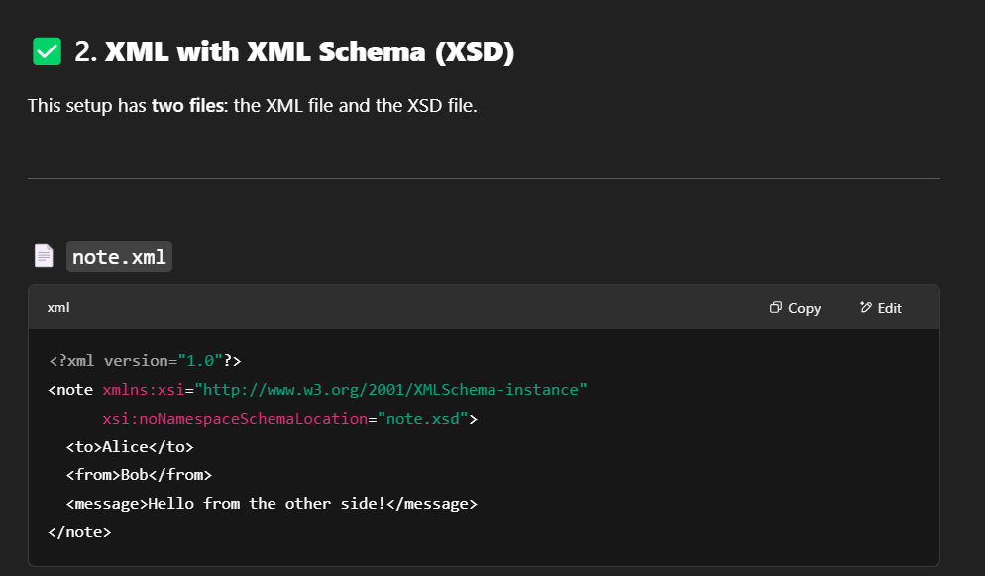

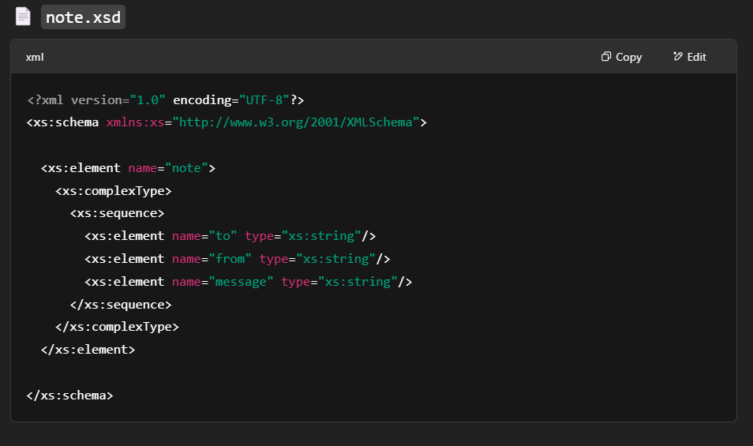

**🗺️ 1. Image Map**

An **image map** allows you to make different parts of an image clickable (like buttons or links). Each area on the image can lead to a different URL or perform a different action.

Think of an image map as a way to create **interactive regions** on one single image.

**🌐 2. HTML Image Map**

In HTML, an image map is defined using the <map> and <area> tags.

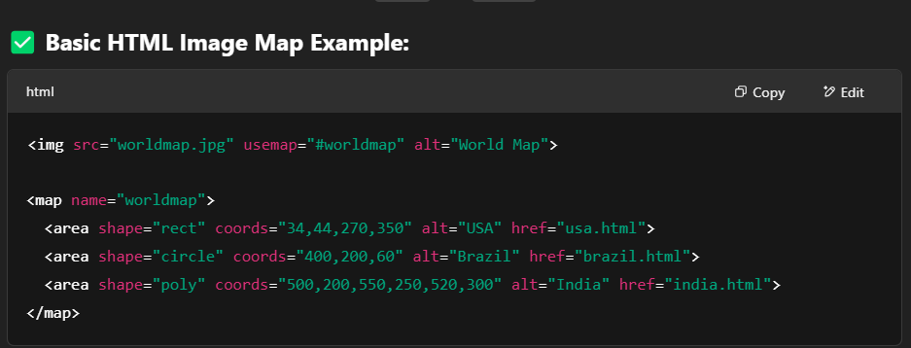

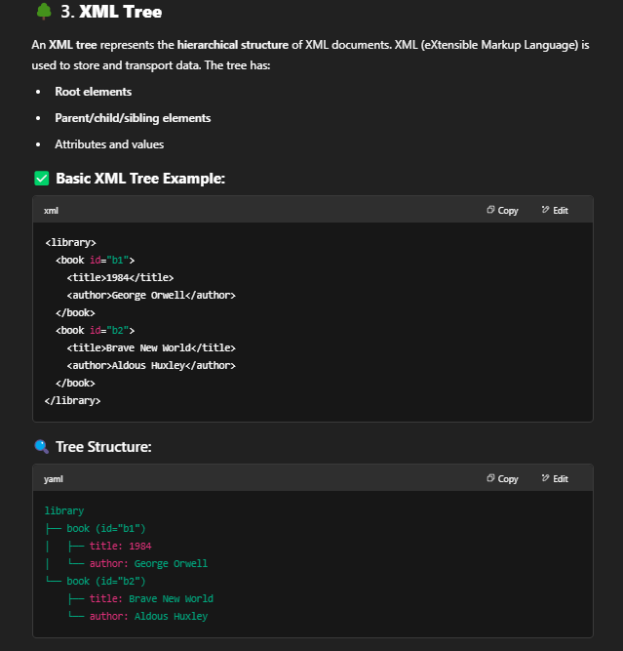

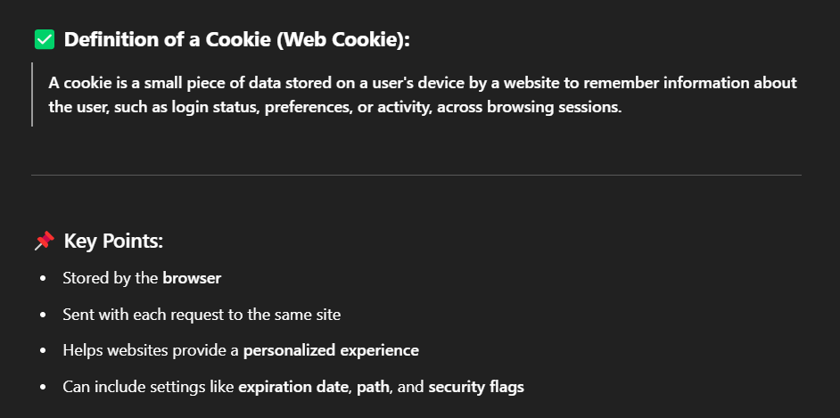

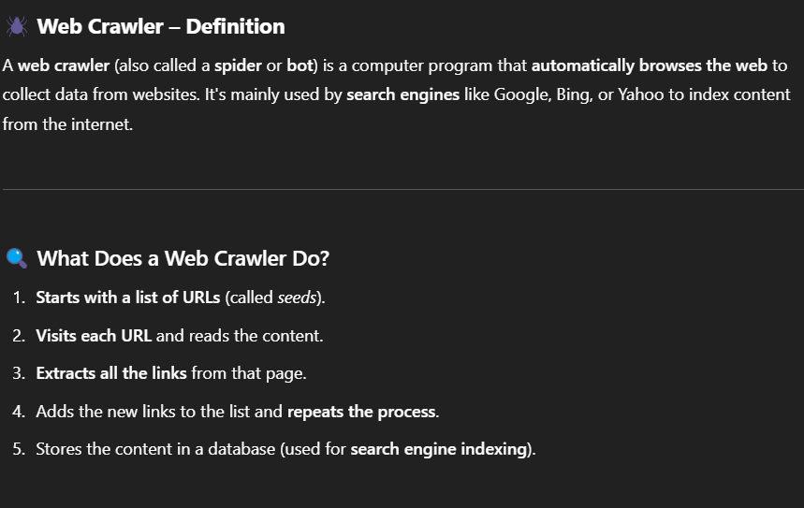

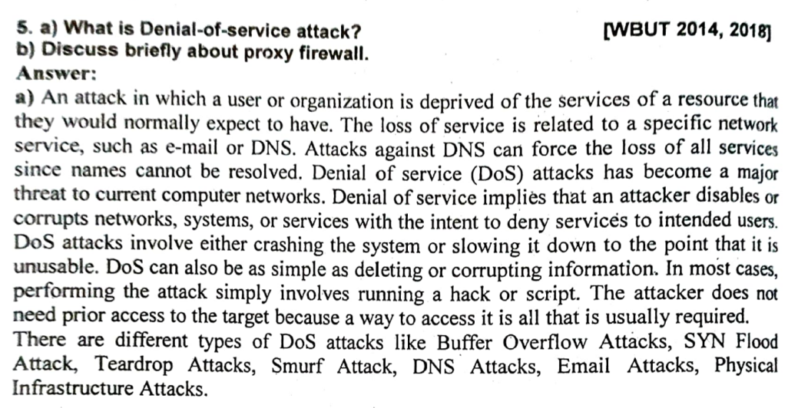

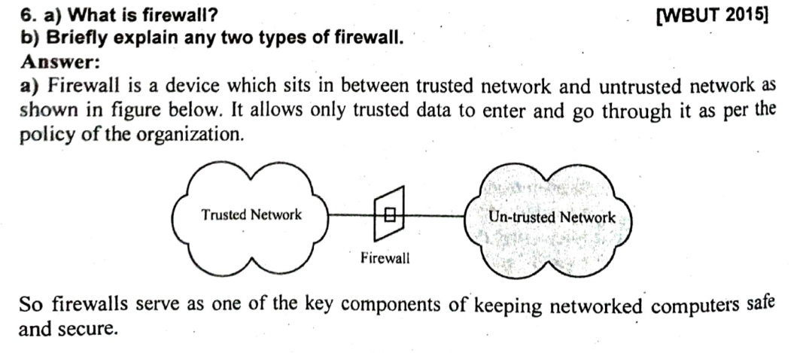

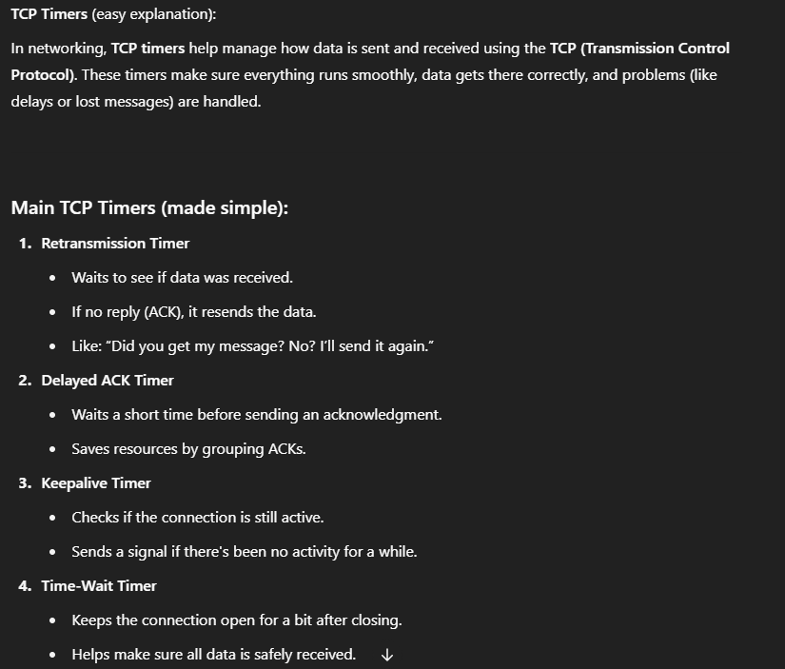

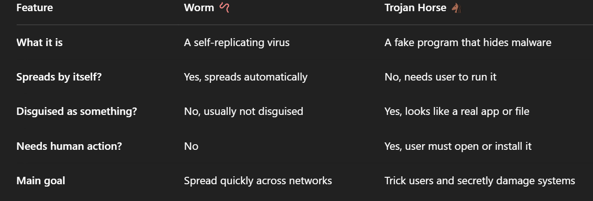

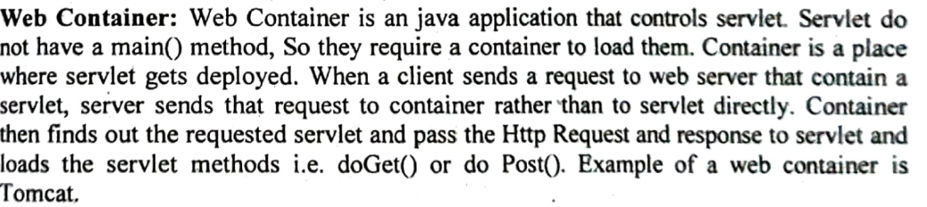

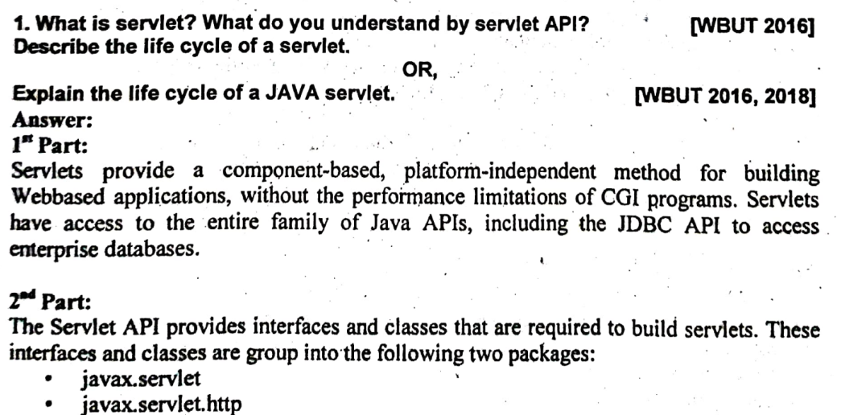

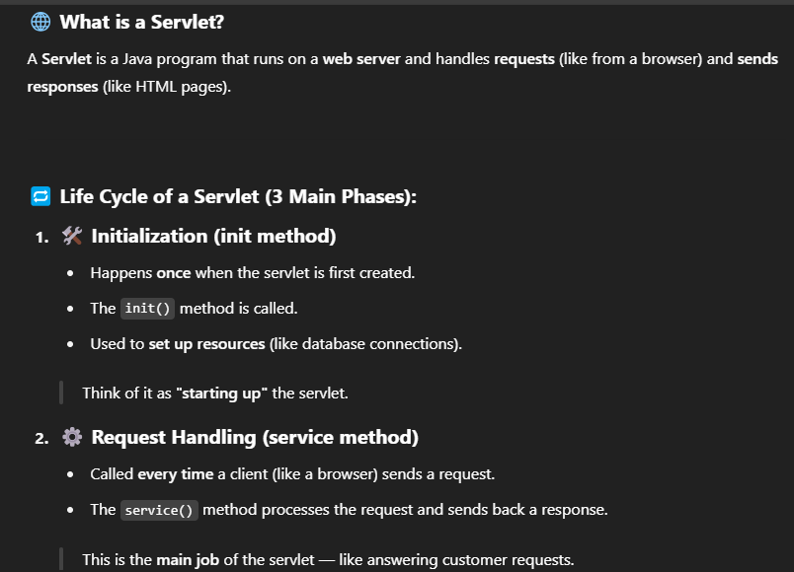

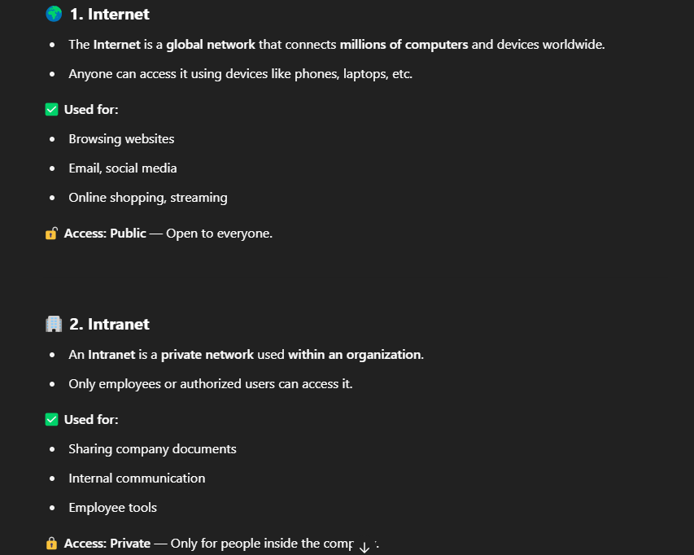

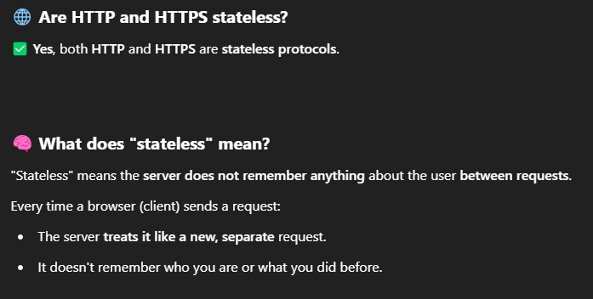

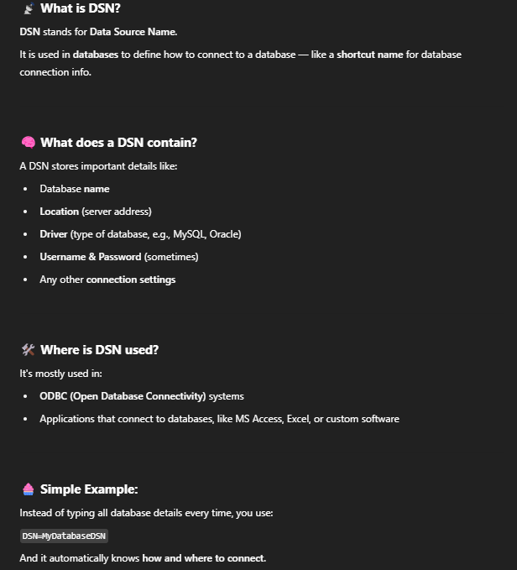

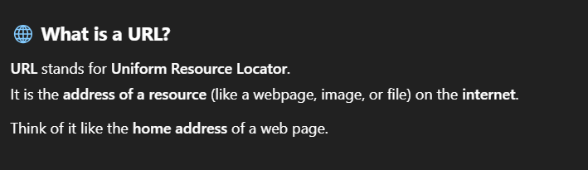

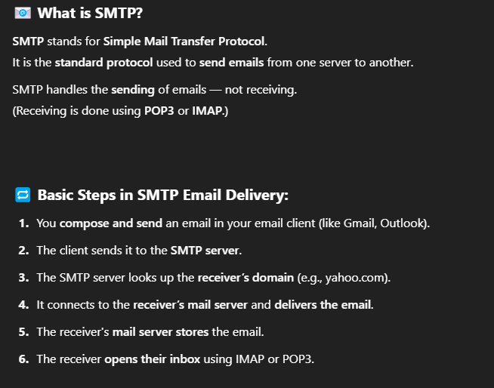

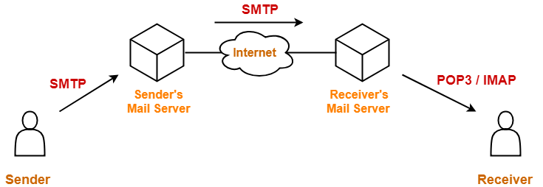

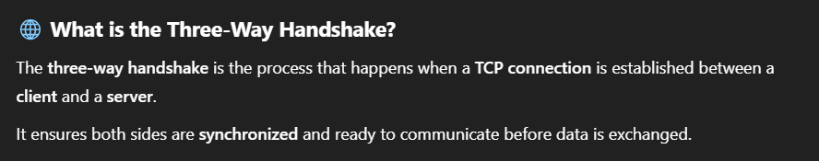

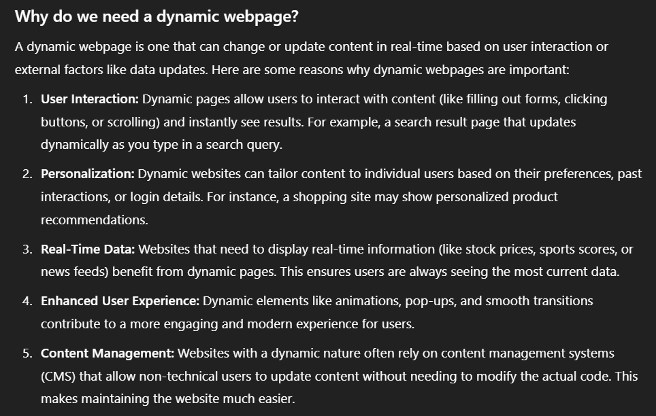

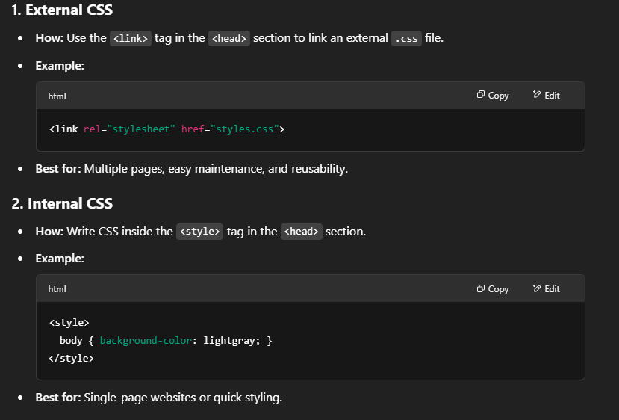

4. Imported CSS:

<style>

@import url('styles.css');

</style>